AdvTechEng, Unit 3: Components and assemblies
Worksheet 5
Describing component shapes and features
1 What do you know about electrical plugs and sockets/outlets in different countries? Describe some specific designs.
2a (3.1) Jan, a project manager for a firm that manufactures electrical plugs & sockets, is briefing some of his engineering colleagues. Listen to the briefing and summarize the aim of the project.
2b What is meant by “profile of the pins and standard configuration”?
2c (3.2) Erin, an engineer with the same company, is describing different electrical plug and socket formats during the briefing. Listen and match the audio descriptions (1-6) to the pictures (a-f).
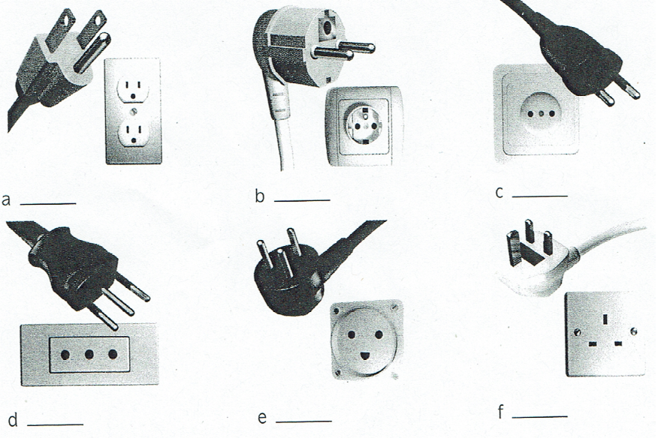
Audio description ; Regions Audio description ; Regions
a) d)
b) e)
c) f)
2d Complete the following phrases from the descriptions using adjectives from the words in brackets.
1 …there are __________________ pins for the live and neutral wire. (circle)
2 ...the earth slot's got a flat base with one side ___________ over to form a semi-circle. (round)
3 This one has ________________________ blades for live, neutral and earth... (rectangle)
4 ... it has a _________________________ slot to receive the earth pin. (cylinder)
5 ... the pins are arranged in __________________ configuration. (line)
6 ... they're laid out in _______________________ configuration. (triangle)
2e (3.3) Listen and underline the stressed syllable in each of the following words.
rectangle rectangular triangle triangular
cylinder cylindrical line linear
3a (3.4) Listen to a longer description from the meeting. Which picture (a - f) in Exercise 2c does Erin describe?
3b Complete the following extracts from the description using the correct form of the words in the box. groove hole pin recess ridge set back flush with Nut, Rille Loch Stift Schlitz Grat, Wulst zurückgesetzt bündig sein mit
1 ...there's a circular slot at the top. It's obviously a blind ____________ , it doesn't go right through.
2 ...there are two plastic ______________________ , one on either side of the plug casing, and
they slot into corresponding ___________________ at each side of the socket. In addition,
the center of the socket is _____________________ . So rather than being _______________
the front of the socket, on the same face, the circular area that receives the plug is _________ from the surrounding casing... 3 These covers only open when pressure is applied to both by the two ____________ of the plug simultaneously.
4 Discuss the advantages and disadvantages of the German plug and socket format. Use the following phrases from the conversation.
an advantage/disadvantage of this format is ...
another advantage/disadvantage is...
the problem with this system is...
this (shape/ format/ feature) stops ... from ... -ing
this (shape/ format/ feature) allows it to.../ helps it to.../ makes it easy to.../ makes it difficult to..

Explaining and assessing manufacturing techniques
5 Think of some examples of machining operations that are often used in manufacturing involving metalworking: a) d)
b) e)
c) f)
6a (3.6) Evan, a sales engineer with a metal fabrication company, is showing Mr Barrett, a new customer, around their plant. Listen to the conversation. Mark the statements true or false.
1 The company specializes in sheet metal working. (Blechverarbeitung)
2 The company does a lot of metal casting. (Metallguss)
3 Metal bashing is a precise technical term for hammering.
4 Drills and milling machines are always noisy. (Fräsmaschinen)
5 Grinding is a process that uses abrasives. (Schleifen, Schmirgeln)
6 The press is used for shearing metal. (Scheren)
6b Complete the training material below for graduate engineers using the following words.
Milling (Fräsen) Sawing (Sägen) Drilling (Bohren) Shearing (Scheren) Flame-cutting (Brennschneiden) Guillotining (Scherschneiden) Key factors in determining the most appropriate cutting technique are: material characteristics (notably hardness as well as thermal and electrical properties), component thickness, component shape and complexity, required edge quality, and production volume. Select cutting options below for a detailed analysis of techniques. Cutting Options
(1)_____________________ : abrasive cutting, removing a kerf of material. Includes cutting with toothed blades and abrasive wheels.
(2)_____________________ : use of pressure on smooth-edged blades for guillotining and punching.
(3)_____________________ : removal of material across the full diameter of a hole, or using hole-saws for cutting circumferential kerfs.
(4)_____________________ : removal of surface layers with multiple cutting wheel passes.
(5)__________________________ : cutting quickly and powerfully with a blade that drops vertically.
(6)____________________________ : using oxy fuel (oxygen + combustible gas, often acetylene).

6c Complete the following definitions using the words in the box.
abrasive wheel guillotine hole-saw kerf punch toothed blade
1 A ______________________ makes holes by applying pressure to shear the material.
2 A ______________________ makes straight cuts by applying pressure to shear the material.
3 A ______________________ is the width of the saw cut.
4 A ________________________________ has sharp edges for cutting or milling.
5 An _______________________________ has a hard, rough surface for cutting or grinding.
6 A ______________________ cuts a circular piece to remove an intact core of material.
7a Read the following extract of promotional literature from a leading producer of ultra-high- pressure (UHP) waterjet cutting machines (Ultrahochdruck-Wasserstrahlschneiden) . Explain the phrases in bold. What makes waterjets such a popular cutting option? Water jets require few secondary operations, produce net-shaped parts with no heat-affected zone, heat distortion, or mechanical stresses caused by other cutting methods, can cut with a narrow kerf, and can provide better usage of raw material since parts can be tightly nested. As a result of the FlowMaster PC control system and intuitive operation, waterjets are extremely easy to use. Typically, operators can be trained in hours and are producing high-quality parts in hours. Additionally, waterjets can cut virtually any material, leaving a satin-smooth edge.
Secondary operations: mechanical stress:
net-shaped parts: narrow kerf:
heat-affected zone: tightly nested:

7b (3.7) Evan is talking to Mr Barrett about UHP waterjet cutting. Listen to the conversation and match the following phrases to the extracts (1 - 4). heat-affected zone mechanical stresses narrow kerf net-shaped parts
Extract 1: ____________________________ Extract 3: ______________________________
Extract 2: ____________________________ Extract 4: ______________________________
7c (3.7) Complete the following extracts from the conversation by underlining the correct phrases.
1 So they are especially good / not so good when you have intricate shapes.
2 Saw blades are obviously perfect / useless when you're cutting curved shapes.
3 ...sawing is the ideal / not the best solution if you want to avoid altering the material.
4 ...it's ideal / totally unsuitable for metals.
8 Study and assess the different cutting techniques on pdf-page 26 of your course reader in terms of a) shape/size of cut, b) material types/characteristics, c) cut width/quality. Learn the phrases in the boxes.
Explaining jointing and fixing techniques
9 Think of some examples of ways of joining materials together.
10a (3.8) Pedro, a purchasing manager with a kitchen appliance manufacturer, is talking to Alicia, a sales manager from one of their main suppliers. Listen to the conversation and answer the following questions.
1 What objective does Pedro describe regarding his company's relationship with suppliers? 2 What is Alicia concerned about? 3 How does he respond to her concerns?
10b Complete the following table using the words in the box. adhesive bolt clip rivet screw weld
Mechanical fixings Non-mechanical fixings a) ___________________ 1) ____________________
b) ___________________ 2) ____________________
c) ___________________
d) ___________________
10c Label the photos (1-6) on p. 27 of your Course Reader (Skript) with the words in Exercise 10b.

10d Match the types of connection in the box to the following groups.
bolting bonding connecting fixing gluing joining riveting welding
1 Describes any kind of connection: __________________ , _________________ , ____________
2 Describes mechanical connections only: ___________________ , __________________
3 Describes non-mechanical connections only: ___________________ , ___________________ ,
______________________
11a Complete the questions below using the following words.
each other on together onto to
1 How can we fix these two components _____________________ ?
2 How can we fix these two components to ______________________ ?
3 How can we fix this component _________ ?
4 How can we fix this component _________ / __________ that component?

11b Complete the following training web page using the words in Exercise 11 a.
MANUFACTURING TECHNIQUE EVALUATION: JOINTS AND FIXINGS The most suitable method of joining components depends on many factors, which extend beyond the obvious issue of required strength.
- Will the joint need to be disconnected in the future? If a part is bolted (1)___________ , it can obviously be removed at a later date. If two components are bonded to (2)__________________ with strong adhesive, or welded (3)____________________then subsequent removal will clearly be more difficult.
- What external factors might affect the joint? Water or heat can weaken adhesive joints. And no matter how tightly nuts are screwed (4) _________ / _______bolts, vibration can cause them to work loose overtime.
- How quality-sensitive is the jointing technique? Components are rarely joined (5) ________ each other in ideal conditions. Inadequately tightened fixings, improperly prepared surfaces, or flawed welds are inevitable. How could such imperfections affect the joint negatively?
11c Answer the following questions using the information on the web page in Exercise 11b.
1 What are the main advantage and disadvantage of mechanical fixings?

2 What is the main disadvantage of non-mechanical jointing?

3 What issues can negatively affect mechanical fixings and non-mechanical joints?

12a Discuss the following jointing techniques used in aircraft. Say how the parts are fixed together.
1 Early aircraft: timber frame / adhesive or screws

2 Modern jet aircraft: alloy body panels / rivets

3 Aircraft cabins: seats/floor/bolts

4 Aircraft cockpit: windshield/fuselage/adhesive

Describing positions of assembled components
13a Read the title of the article and suggest ways of making a garden chair fly. Discuss any potential problems.
13b Read the article and match the questions (a - d) to the paragraphs (1 - 4).
a) How did the actual flight differ from the one that was planned?
b) What incidents occurred just before and just after the landing?
c) What is said about the modern equivalent of this type of activity?
d) What components were used to assemble the flying machine?
CRAZY BUT TRUE: LARRY WALTERS AND THE FLYING GARDEN CHAIR On July 2, 1982, a Californian truck driver named Larry Walters sat outside his house on a garden chair. To say that he was out to get some air is an understatement, for projecting above him a cluster of ropes was tied to 42 helium-filled weather balloons. Anchor ropes, situated underneath the chair, were fastened around the bumper of his car, which was positioned just below the makeshift flying machine.
Mr Walters intended to climb gently to an altitude of a few hundred feet, before drifting slowly out of town and across country. He then planned to use an airgun to shoot some balloons and descend gradually to earth. But as the helium gas contained within the balloons warmed up in the summer sun, it progressively generated more lift. When the anchor ropes were released, the self-assembly airship shot up like a rocket. Too shocked to reach for the pistol inserted in his pocket, the first-time pilot held on for life. In just a few minutes, Larry Walters was 16,000 feet above the ground, floating over the city of Long Beach. A short time later, there were further complications; he suddenly found himself inside controlled airspace, adjacent to Long Beach Airport. The occupants of passing Delta Airlines and TWA aircraft looked on at the curious spectacle outside, as wide-eyed as the garden chair pilot hovering beside them.
Eventually, after managing to shoot some balloons, Mr Walters descended safely to earth despite an anchor rope, which was still suspended beneath the chair, getting tangled with a power line located alongside the landing site (in someone's garden). He was immediately arrested by waiting police officers, and was later fined for breaking Federal aviation laws.
Today, cluster ballooning, while still a fairly marginal sport, is steadily starting to gain in popularity.
14a Label the diagrams using the prepositions in the box. above adjacent to alongside around below beneath beside inside outside underneath within over
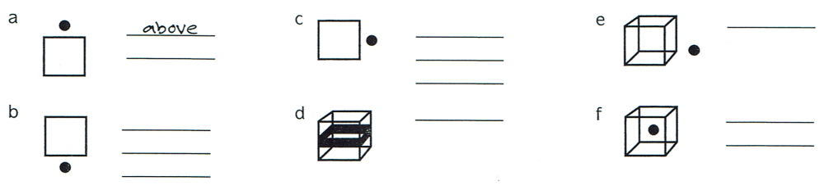
14b Complete the following sentences about the flying garden chair using the prepositions in the box. Check your answers against the text in Exercise 13b.
in above around beneath within
1 Projecting _____________ the chair was a cluster of ropes, tied to 42 helium-filled weather balloons.
2 Anchor ropes were fastened _________________ the bumper of the car.
3 Larry Walters had an airgun inserted ________ his pocket.
4 The helium contained _________________ the balloons warmed up in the sun.
5 After takeoff, the anchor ropes remained suspended ___________________ the chair.

14c Complete the following descriptions of how the garden chair airship was assembled by underlining the correct words.
- A quantity of helium gas was contained / suspended inside each balloon.
- A tube was inserted / projected inside the openings of the balloons, to inflate them.
- The balloons were situated / suspended over the chair, in a large cluster.
- The chair was contained / suspended under the balloons by ropes.
- Arm rests, contained / located beside the pilot, at each side, helped to hold him in place.
- The landing gear, inserting / projecting below the seat, consisted, simply, of the chair legs.
- The pilot was positioned / projected underneath the balloons, so his weight was low down.

14d Which two other words have the same meaning as positioned ? contained fastened inserted located projected situated suspended

